**Smart Meters and Energy Demand Management**

**Full Unit Project: Report 1  
Benedict Wilkins**

**Supervisor: Zhiyuan Lou**

**2016**

**Energy Demand Management**

Energy Demand Management (EDM) is in essence about managing the consumption/production of energy to ensure an effective energy network and to minimize cost and environmental damage. One of the main issues that EDM faces is how to manage and efficiently supply energy to consumers. Peaks in energy demand arise when consumers – domestic or industrial, have synchronized habits. These lead to energy demand fluctuations (EDF), daily, weekly and seasonally [[1]]. These fluctuations must be dealt with by energy provides so not to result in damage to the energy network, blackouts and unpredictable service.

**Techniques for Supply Management**

There are two general categories of power plant; base load and peaking. Base power plants are used to handle the base load power supply – the minimum requirement of energy over a period of time. They are usually nuclear, coal or large hydro-electric plants [[2]]. These plants are only turned off for maintenance or upgrades and usually provide the base power supply to a large area. Peaking power plants are one way to deal with EDF, they will produce a varying amount of power to keep up with demand and can be turned on and off with relative ease. They are often small gas/coal burning plants. See Figure 1.

Other techniques are used include energy storage and energy purchasing. Energy storage involves store a large amount of energy and releasing it back to the grid during peak times. One of the most common examples of large-scale energy store are hydroelectric dams/pumps. Water may pumped during non-peak times or naturally build up behind a dam, later to be let through the turbines at peak times. One problem with pumping is that not all of the energy will be recovered as some will be lost during the process. Energy purchasing is when an energy provider buys in energy from a separate grid. An example may be a British energy provider buying power from the French natation grid. Depending on the energy market this may be more desirable than using their own grid infrastructure such as peaking plants and storage due to cost.

**Demand Side Management and Smart Meters**

Moving to the consumer side of EDM. Another way of approaching the problem and is to alter the habits of the consumers to reduce EDF. This will result in reduced cost for energy providers and consumers. Demand response (DR) uses financial incentives to encourage consumers to alter their energy consumption habits. This method has been testing in the health sector, trying to alter habits that relate to health by heavily taxing cigarettes and alcohol for example and has been shown to be effective [[3]]. There have been various models that support DR in this projects context, see [[4]]. With the advent of smart meters and their increasing popularity in the market, it is now possible to collect house-hold specific data. The National Grid (NG) in the UK has previously had meters to monitor electricity demand on a larger scale (making the data in figure 1 possible to obtain). Now that data can be collected directly from the end point it is possible to implement DR by tailoring pricing in a way that reduces EDF and benefits the consumer.

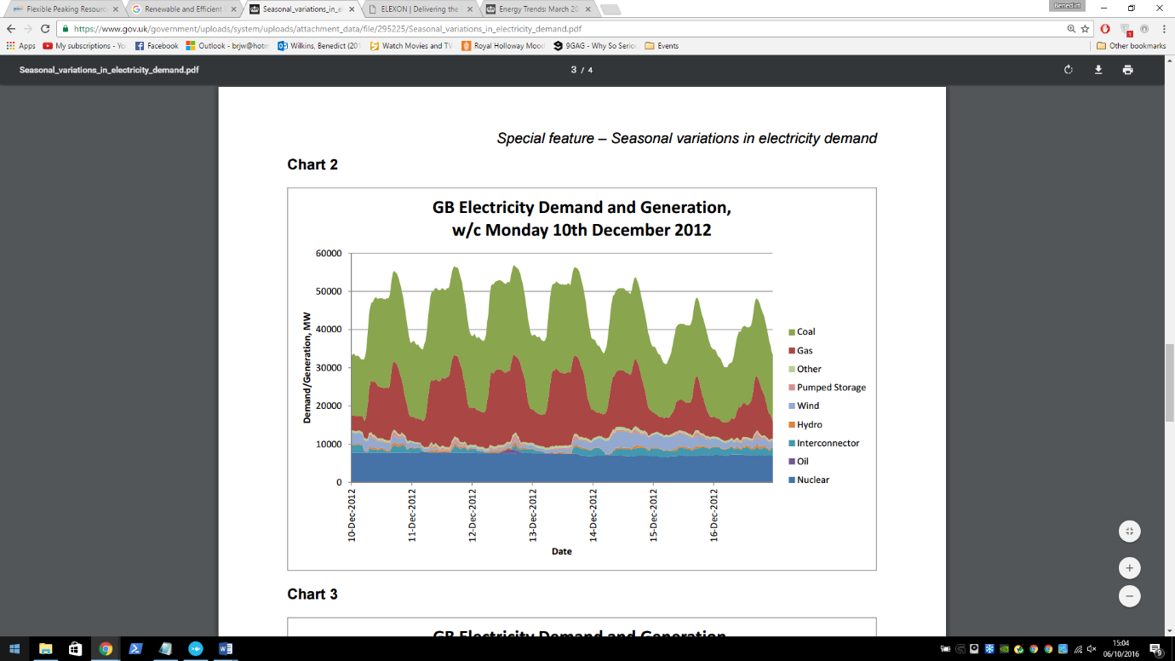

**Figure 1**. Taken from Special feature – Seasonal variations in electricity demand. See bibliography entry (Gaven, 2014).  
The above shows the power demand/generation on the GB National Grid from 10 – 16 of December 2012 starting at midnight (00:00). It illustrates the daily energy demand fluctuations and shows the use of peaking and base load power plants. Nuclear power plants are shown here to be the base load power plants. It is clear to see that gas and coal fire power plants are being used to deal with the EDF and so are the peaking power plants.

**Data Collection in Context**

It is important to look at the type of data that the system to be developed will be using. According to the Smart Metering Implementation Program [[5]] *‘GSME shall be capable of recording Consumption in each thirty minute period’.* (Gas Smart Metering Equipment – GSME), the same applies for Electric Smart Metering Equipment (ESME). There is also a daily data recording option however this option will not be suitable for the predictions that this project is concerned with. In principle the system will be able to support any reasonable time scale, but the most useful will be on an hourly time scale. The implementation details of the smart meter or what type of meter is irrelevant as long as the data is useable. Useable data will be some data collected at regular time interval. With this in mind, the system isn’t necessarily limited to house-holds. Data may be collected from businesses/industrial settings. However it may be useful to make the distinction between the two as the scale of the data will be very different when comparing household to a factory. The relevance of this will be discussed in a later report on data pre-processing that will be presented with the data pre-processor program.

**Motivations**

Machine learning is a fast developing and heavily researched area in computing and is well suited to helping achieve this goal. Machine learning models require a few things to work – lots of data and a pattern. In this case data will be readily available from a large number of smart meters around the country. There is a pattern - looking a figure 1 gives a good indication that there is at least a day to day pattern. ANNs should be able to model this pattern effectively and provide good predictions as a result. ANNs have been used previous to forecast for arguably more complex system including the stock market.

Using a multi-agent framework will provide a flexible but robust structure for the system, it allows the system to be easily distributed. This will be key if the system is to scale well. Using agents allows easy experimentation in data pre-processing and communication (to be discussed in the later Multi-agent Systems report).

DR may provide a cheaper alternative to the supply management solutions presented above. There are some problems it cannot solve – for example large EDF when weather/seasons change, but it shows potential in helping reduce EDF on a day to day scale. Utilising Smart meters and current computing technology to create a more efficient energy grid will help reduce our impact on the environment and reduce cost for everyone involved. Using the system to be developed will provide a means to this goal.

# **Bibliography**

Antonios Chrysopoulos, C. D. (2013). Agent-based small-scale energy consumer models for energy portfolio management. *2013 IEEE/WIC/ACM International Joint Conferences on (Vol. 2, pp. 94-101). IEEE.*

Department of Energy & Climate Change. (2014). *Smart Metering Implementation Programme, Smart Metering Equipment Technical Specifications.* Department of Energy and Climate Change.

Emma L. Giles, S. R. (2014). The Effectiveness of Financial Incentives for Health Behaviour Change: Systemtic Review and Meta-Analysis.

European Nuclear Society. (n.d.). *Base load power plants*. Retrieved from euronuclear: https://www.euronuclear.org/info/encyclopedia/baseloadpowerplants.htm

Gaven, C. (2014). *Seasonal variations in electricity demand.* Department of Energy & Climate Change.

Smart Energy GB. (n.d.). *About the rollout*. Retrieved from smartenergygb: https://www.smartenergygb.org/en/the-bigger-picture/about-the-rollout

1. (Gaven, 2014)
2. (European Nuclear Society, n.d.)
3. (Emma L. Giles, 2014)
4. (Antonios Chrysopoulos, 2013)
5. (Department of Energy & Climate Change, 2014)